## Artificial Intelligence and

## Machine Learning

Project Report

Semester-IV (Batch-2022)

NeuroVision: Forecasting Health on the Spectrum

**Supervised By: Submitted By:**

Faculty Name – Dr. Kiran Deep Singh Name – Group 1 – APSC

Roll Number – 2210990333

2210990331

2210990335

2210990642

Group – G-8

**Department of Computer Science and Engineering**

## Chitkara University Institute of Engineering & Technology,

## Chitkara University, Punjab

## Introduction

* 1. **Background**

In recent years, healthcare has changed a lot because of technology, especially in predicting medical conditions. This change is driven by machine learning, big data, and digital health tools, making it easier and faster to diagnose and treat patients. People around the world now use these tools to get better health outcomes.

This digital change in healthcare brings many benefits. It makes diagnosing health problems more precise and quicker. Traditional methods, which often take a long time and might not be very accurate, are being replaced by advanced tools. Doctors can now predict, diagnose, and treat conditions more efficiently, and patients benefit from early detection and treatment, which improves their health and lives.

However, using predictive analytics in healthcare also has challenges. Ensuring the predictions are accurate is crucial because mistakes can lead to wrong diagnoses or delayed treatment, harming patients. Also, integrating these technologies into current healthcare systems raises issues about ethics, privacy, and security, especially when handling sensitive patient information.

Several factors drive the rise of predictive healthcare analytics. These include better machine learning techniques, more available large datasets, and the growing need for personalized medicine. Researchers and healthcare professionals continuously improve their models, using advanced algorithms to analyze large amounts of health data to find patterns and predict disease outcomes. This process involves combining different data sources, like electronic health records, patient’s origin, and other features, to create comprehensive and accurate predictive models.

To address these challenges and opportunities, our project aims to use advanced machine learning and data analytics to predict several important health conditions: COVID-19, autism in both toddlers and adults, stroke, and Parkinson’s disease. By analyzing large health datasets and considering various factors like demographic information, clinical history, and genetic markers, these models can identify risk factors, predict disease onset, and help in early intervention.

Our project includes different datasets for each disease. These datasets are specific to each condition and cannot be merged into a single dataset because they do not have common features. Each dataset requires a tailored approach to analyze and predict the specific health condition accurately.

Predictive analytics in healthcare has changed how diseases are managed and prevented. For example, during the COVID-19 pandemic, predictive models helped forecast infection rates, find hotspots, and guide public health decisions. In autism, early diagnosis and intervention are crucial, and predictive models can help spot early signs in toddlers and track the condition in adults. Stroke prediction models can give early warnings, allowing quick responses and reducing severe outcomes. For Parkinson’s disease, predictive analytics can help in early diagnosis and monitor the disease’s progression, improving patients' quality of life.

A significant challenge in developing predictive models for healthcare is balancing accuracy and understandability. Complex models like deep learning can be very accurate but are hard to understand. Simpler models might be easier to understand but less accurate. Finding a balance is essential to make sure predictive models are both reliable and usable in clinical settings.

In summary, using predictive analytics in healthcare offers a great chance to improve how we diagnose and treat medical conditions. By leveraging machine learning and data analytics, we can develop strong predictive models to tackle critical health issues, ultimately enhancing health outcomes and advancing personalized medicine.

* 1. **Objectives**

1. **Developed Machine Learning Models for Health Predictions:**

**Used diverse health datasets:**

Collected and used historical health data for each specific condition (COVID-19, autism in toddlers and adults, stroke, and Parkinson’s disease). This data helped the models understand patterns and trends, allowing them to learn the differences between healthy and unhealthy states.

**Explored various machine learning algorithms**:

Tried different machine learning algorithms for each health condition. These algorithms include methods like logistic regression, decision trees, random forests, support vector machines (SVM). Testing various algorithms helps us find the best one for each condition based on the data and the complexity of predicting the condition.

**Performed data preprocessing:**

Prepared the datasets by handling missing values, outliers, and categorical variables. Used techniques like normalization, standardization, and feature scaling to make sure the data is clean and consistent. Good data preparation is essential for training effective machine learning models.

**Conducted feature selection:**

Identified the most important features or attributes in the data that help distinguish between different health conditions. Used techniques like recursive feature elimination, feature engineering, or correlation analysis to select these features. This step helps reduce the number of variables, making the models simpler and more efficient.

**Evaluated model performance:**

Measured how well each machine learning model performs using metrics like accuracy, precision, recall, and F1-score. Performed cross-validation to test the models on different subsets of data, ensuring they can generalize well to new, unseen data. Used tools like confusion matrices to understand the balance between false positives and false negatives.

**Tailored models for each condition:**

Developed specific models for each health condition since they have unique features and patterns. COVID-19, autism, stroke, and Parkinson’s disease all require individual approaches due to their distinct characteristics. This tailored approach ensures that the models are highly accurate for each condition.

**Ensured practical application:**

Made sure that the models are not only accurate but also easy to understand and used by healthcare professionals. Balanced the complexity of the models with their interpretability so that doctors and other medical staff can trust and effectively use the predictions in their practice.

1. **Achieved High Accuracy:**

**Striked a balance between false positives and false negatives:**

Aimed to minimize both false positives (incorrectly predicting someone has a condition when they don't) and false negatives (failing to predict a condition when someone actually has it). This balance is crucial to ensure accurate predictions while avoiding unnecessary stress for patients and missed diagnoses. For example, in stroke prediction, we want to correctly identify those at risk without causing alarm for those who are not.

**Optimized performance metrics:**

Focused on optimizing performance metrics such as precision, recall, and the F1-score for each health condition. Precision measures the accuracy of positive predictions (e.g., correctly predicting a disease when it is present), recall measures the ability to identify all actual positive cases (e.g., detecting all cases of autism in toddlers), and the F1-score provided a balanced assessment of precision and recall. These metrics helped ensure the models are both accurate and reliable.

**Fine-tuned model parameters:**

Adjusted the parameters of each machine learning model to improve performance. This included tweaking settings like regularization parameters, learning rates, and thresholds. For example, adjusting the learning rate can help the model learn more effectively from the data. This fine-tuning process involves experimenting with different settings and evaluating their impact on the model's accuracy and stability for conditions like Parkinson's disease or COVID-19.

**Continuously monitor and update the model:**

Set up systems to regularly monitor and update the predictive models to adapt to new data and changing patterns. This means continually retraining the models with new health data and incorporating feedback from real-world performance. For example, as new data on COVID-19 variants emerge, the model should be updated to maintain high accuracy. Regular updates help keep the models accurate and effective over time.

1. **Implemented Scalable Solution:**

**Designed modular and adaptable software components:**

Developed a health prediction system with modular software components that can easily fit into existing healthcare systems. This modular design allows for scalability and allows for updates and improvements to the system's architecture without disrupting existing functionalities. For example, each health condition prediction module can be developed independently and integrated seamlessly into the overall system architecture.

**Leveraged distributed computing and parallel processing:**

Utilized distributed computing and parallel processing techniques to efficiently handle large volumes of health data. Technologies enabled parallel processing of data across multiple servers or nodes, improving scalability and performance. This approach ensures that our prediction system can handle increasing data volumes without sacrificing speed or accuracy.

**Implemented batch and data processing:**

Supported both batch processing and data processing of health data to accommodate different use cases and requirements. Batch processing allows us to analyze large historical datasets, This flexibility ensures that our prediction system can handle both historical data analysis and predictions effectively.

**Monitored system performance and scalability:**

Continuously monitored the performance and scalability of the prediction system to identify any bottlenecks and optimize resource utilization. Implement monitoring tools and performance metrics to track system health, response times, throughput, and resource usage. By monitoring system performance, we can proactively identify and address any issues to ensure that our prediction system remains scalable and reliable.

By implementing these scalable solutions, we aim to develop a robust and efficient health prediction system that can handle large volumes of data and adapt to changing workload demands. This ensures that our prediction system remains accurate, reliable, and cost-effective, ultimately improving health outcomes for patients.

* 1. **Significance**

The significance of this project lies in its potential to revolutionize healthcare through advanced predictive analytics, improving patient outcomes, enhancing the efficiency of healthcare systems, and advancing medical research. Here’s how this project can make a significant impact:

1. **Patient Protection and Care :**

**Early Detection and Treatment:**

This project helps in the early detection of serious health conditions such as COVID-19, autism, stroke, and Parkinson's disease. Early diagnosis can lead to timely treatment, significantly improving patient outcomes and quality of life. For example, early intervention in autism can greatly enhance developmental outcomes for toddlers.

**Personalized Healthcare:**

By using predictive analytics, healthcare can become more personalized. This means that treatments and interventions can be tailored to individual patient needs, leading to more effective and efficient healthcare. Patients benefit from treatments that are specifically suited to their health profiles, reducing the trial-and-error approach of traditional methods.

**Peace of Mind:**

Patients and their families can feel more secure knowing that advanced technology is being used to monitor and predict health conditions. This reassurance can reduce anxiety and stress associated with uncertainty about health issues, promoting a better overall patient experience.

2. **Support for Healthcare Providers:**

**Improved Diagnostic Accuracy:**

Healthcare providers benefit from tools that enhance diagnostic accuracy. Predictive models provide additional insights that can help doctors make more informed decisions, reducing the likelihood of misdiagnosis and ensuring appropriate care.

**Efficient Resource Allocation:**

Predictive analytics can help healthcare providers allocate resources more effectively. For example, by identifying patients at high risk of stroke, hospitals can ensure that necessary preventive measures and treatments are available, optimizing the use of medical resources.

**Streamlined Workflow:**

Integrating predictive models into healthcare systems can streamline workflows, making it easier for providers to identify at-risk patients and prioritize their care. This can lead to more efficient clinical operations and better patient management.

**Enhanced Patient Quality of Life:**

Accurate and early predictions can lead to timely and appropriate interventions, which can significantly improve the quality of life for patients. For instance, early detection of Parkinson’s disease can help in managing symptoms better and delaying disease progression, thereby enhancing patients' daily lives.

**3.Advancements for Researchers:**

**Enhanced Data Utilization:**

This project leverages large datasets to uncover patterns and trends that might not be evident through traditional research methods. Researchers can gain new insights into the development and progression of diseases, leading to potential breakthroughs in medical science.

**Facilitation of New Studies:**

The models and data used in this project can serve as a foundation for future research. By providing a robust analytical framework, this project can help researchers design new studies and experiments, further advancing our understanding of various health conditions.

1. **Industry Integrity:**

**Collaborative Efforts:**

The project’s contribution to improving health predictions enhances the overall integrity and effectiveness of the healthcare system. By developing robust and reliable predictive models, the project sets a high standard for accuracy and security in health data analytics. This collective effort ensures that healthcare predictions are trustworthy and beneficial, promoting a culture of precision and care.

**Innovation and Growth:**

A secure and reliable environment for health data encourages innovation and growth within the healthcare industry. By reducing the risks associated with inaccurate health predictions, the project creates a conducive atmosphere for exploring new technologies, expanding healthcare services, and embracing digital health advancements. This environment fosters the development of new diagnostic tools, treatments, and preventive strategies, driving the future of healthcare forward.

**Consumer Confidence:**

The success of predictive health models relies on the confidence and trust of patients and healthcare providers. By implementing stringent data security measures and ensuring high accuracy, the project boosts trust in predictive analytics. This increased confidence leads to more widespread adoption of these technologies, improving health outcomes and making healthcare delivery more efficient and effective.

In essence, the significance of the project transcends individual health predictions. It encompasses broader implications for patient care, healthcare innovation, and the overall integrity of the medical field. Through a commitment to precision, security, and continuous improvement, the project fosters a safer, more resilient, and trustworthy healthcare environment.

1. **Problem Definition and Requirements**

**2.1 Problem Definition**

Predicting various health conditions using machine learning involves creating models capable of accurately identifying the likelihood of diseases based on diverse datasets. Each health condition—COVID-19, stroke, autism in toddlers, and Parkinson's disease—presents unique challenges and requires different predictive approaches due to the specific nature of the data involved.

**COVID-19 Outbreak Prediction Using Machine Learning:**

COVID-19 is an infectious disease caused by the novel coronavirus, first identified in Wuhan, China, in December 2019. The disease spreads primarily through respiratory droplets and can cause symptoms ranging from mild respiratory illness to severe complications. Effective prediction of COVID-19 outbreaks can help in timely interventions and resource allocation. The primary challenge is to develop models that can accurately predict new outbreaks based on historical data, which includes the number of confirmed cases, recoveries, deaths, and other relevant factors. This task involves analyzing trends, seasonal patterns, and other variables to make reliable predictions.

**Stroke Prediction Using Machine Learning:**

Stroke is a major health concern worldwide, being a leading cause of death and long-term disability. The goal here is to predict the likelihood of a stroke based on various health parameters and patient demographics. The primary challenge involves accurately modeling the risk factors for stroke, such as age, hypertension, heart disease, lifestyle choices, and other medical conditions. Machine learning models need to analyze these complex interactions and predict the risk of stroke, enabling early intervention and preventive care.

**Autism Prediction in Toddlers Using Machine Learning:**

Early detection of autism in toddlers can significantly impact treatment and management, improving long-term outcomes. The challenge lies in developing a predictive model that can accurately identify the likelihood of autism based on a variety of screening questions, demographic information, and family history. The model must be capable of distinguishing subtle patterns in the data that indicate the presence of autism, making it a valuable tool for early diagnosis.

**Parkinson’s Disease Prediction Using Machine Learning:**

Parkinson's disease is a progressive neurological disorder that affects movement and can lead to severe disability. Predicting the likelihood of Parkinson's disease involves analyzing biomedical voice measurements and other clinical data to detect early signs of the disease. The primary challenge is to develop models that can accurately identify these early signs, enabling timely diagnosis and treatment.

**General Challenges Across Health Condition Predictions:**

* **Data Volume and Variety:** Each health condition dataset contains a vast amount of data, often with varying formats and structures. Managing and processing this data efficiently is crucial for accurate predictions.
* **Feature Complexity:** Each dataset involves multiple features that interact in complex ways. Machine learning models must be able to capture these interactions to make accurate predictions.
* **Continuous Learning:** Health conditions and their indicators can evolve over time. Models need to be continuously updated with new data to maintain their accuracy and relevance.
* **Integration with Existing Systems:** Implementing these predictive models within existing healthcare systems involves overcoming technical barriers, ensuring compatibility, and adhering to regulatory requirements.

**Implementation Challenges:**

* **Algorithmic Complexity:** Developing sophisticated algorithms that can accurately predict health conditions involves complex statistical and computational techniques.
* **Model Integration:** Seamlessly integrating machine learning models within healthcare systems, ensuring they work alongside existing processes and tools, is a significant challenge.
* **Regulatory Compliance:** Ensuring that predictive models comply with healthcare regulations and standards is essential for their adoption and use.
* **Monitoring and Validation:** Continuously monitoring model performance and validating predictions to avoid false positives and negatives is crucial for maintaining trust and efficacy.

By addressing these challenges and leveraging advanced machine learning techniques, this project aims to develop robust predictive models that can accurately identify the likelihood of various health conditions, thereby improving early diagnosis, treatment, and overall healthcare outcomes.

**2.2 Requirements**

**Software Requirements:**

**1. Python:**

Python is selected as the primary programming language for its widespread use, reliability, and extensive support for data science and machine learning tasks. Its readable syntax and large community make it a perfect choice for both newcomers and seasoned developers.

**2. Libraries:**

Scikit-learn: This library offers a simple and efficient set of tools for data mining and data analysis, making it crucial for building machine learning models. It provides various algorithms for classification, regression, clustering, and more.

Pandas: Pandas is used for data manipulation and analysis, offering structures like DataFrame for easy handling of structured data. It provides functionalities for filtering, grouping, joining, and reshaping datasets, essential for preprocessing tasks.

NumPy: NumPy is fundamental for numerical computing in Python, supporting large, multi-dimensional arrays and matrices. It offers a wide range of mathematical functions, enabling efficient handling of numerical data.

Matplotlib: Matplotlib is a plotting library that allows the creation of static, animated, and interactive visualizations in Python. It provides a MATLAB-like interface for generating plots, histograms, scatterplots, and more, aiding in data exploration and presentation.

Seaborn**:** Seaborn is a statistical data visualization library based on Matplotlib. It provides a high-level interface for drawing attractive and informative statistical graphics, making it easier to create complex visualizations.

Plotly: Plotly is an interactive graphing library that allows the creation of interactive, publication-quality graphs online. It supports a variety of chart types and is particularly useful for creating dashboards and interactive plots.

**3. IDE:**

Jupyter Notebook: Jupyter Notebook is a web-based interactive computing environment widely used for data analysis, scientific computing, and machine learning. It allows users to create and share documents containing live code, equations, visualizations, and narrative text, fostering collaboration and reproducibility.

Preferred IDE: While Jupyter Notebook is recommended for its interactivity and ease of sharing, developers can choose any Python Integrated Development Environment (IDE) they prefer, such as PyCharm, Visual Studio Code, or Spyder. These IDEs offer features like code completion, debugging, and version control integration, enhancing the development experience.

**Hardware Requirements:**

The project is designed to run on standard laptop or desktop computers with the following specifications: RAM A minimum of 8GB RAM is recommended to ensure smooth execution of data processing and model training tasks. Larger datasets or more complex models may require additional memory.

Processor: A multi-core processor, preferably with higher clock speeds, is desirable for faster computation. While modern CPUs from Intel or AMD are suitable, dedicated GPUs can also accelerate certain machine learning tasks, though they are not strictly required for this project.

Memory: At least 8 GB of RAM, though 16 GB is recommended for handling large datasets and complex computations without performance issues.

Storage: A solid-state drive (SSD) with a minimum of 256 GB of free space to ensure fast data access and sufficient storage for datasets and software.

Graphics Processing Unit(GPU):

A dedicated GPU with at least 4 GB of VRAM is beneficial for deep learning tasks, which can significantly speed up the training process.

**Data Requirements:**

COVID-19 Data: Daily level information on the number of confirmed cases, deaths, and recoveries from COVID-19, ideally from a reliable source such as public health databases or Kaggle.

Stroke Data: Patient data including age, gender, medical history, lifestyle factors, and health conditions, gathered from medical records or health surveys.

Autism Data: Screening results, demographic information, family history, and other relevant details about toddlers and adults, collected through standardized autism screening tests.

Parkinson’s Data: Biomedical voice measurements and other clinical data related to Parkinson’s disease, sourced from health studies or specialized databases.

The dataset used for this project is sourced from Kaggle. By adhering to these software, hardware, and data requirements, this project aims to develop robust predictive models for various health conditions, thereby enhancing early diagnosis and treatment strategies.

Exploring the dataset thoroughly before model development is crucial to understand its characteristics, potential biases, and challenges. This exploration phase helps in selecting appropriate preprocessing techniques, feature engineering strategies, and evaluation metrics for building effective fraud detection models.

**Dataset Overview**

The project utilizes different datasets for each health condition: COVID-19 outbreak prediction, stroke prediction, autism detection in toddlers, and Parkinson's disease prediction. Below is an overview of the attributes included in each dataset.

**COVID-19 Outbreak Prediction:**

|  |  |
| --- | --- |
| Feature | Description |
| Confirmed | Number of persons confirmed to have COVID-19. |
| Deaths | Number of persons who died due to COVID-19. |
| Recovered | Number of persons who recovered from COVID-19. |
| Province/State | Province or State where COVID-19 is spreading |
| Country | Country where COVID-19 is spreading |
| Latitude | Latitude of the location |
| Longitude | Longitude of the location |
| Date | Date of the record update |
| Active | Number of active cases. |
| WHO Region | WHO geographical region |

Table 1

**Stroke Prediction:**

|  |  |
| --- | --- |
| Feature | Description |
| id | Unique identification number. |
| Gender | "Male", "Female", or "Other" |
| Age | Patient’s age. |
| Hypertension | 0 if no hypertension, 1 if patient has hypertension. |
| Heart_disease | 0 if no heart disease, 1 if patient has heart disease. |
| Ever_married | “No” or “Yes” |
| Work_type | "children", "Govt_job", "Never_worked", "Private", or "Self-employed" |
| Residence_type | "Rural" or "Urban" |
| Avg_glucose_level | Average glucose level in blood |
| bmi | Body mass index. |
| Smoking_status | "formerly smoked", "never smoked", "smokes", or "Unknown" |
| stroke | 1 if patient had a stroke, 0 if not |

Table 2

**Autism Detection in Toddlers:**

|  |  |
| --- | --- |
| Feature | Description |
| Case_No | Unique ID for each toddler |
| A1 to A10 | Results of autistic screening questions |
| Age_Mons | Age of the toddler in months |
| Qchat_10Score | Total score of the screening questions |
| Sex | Gender of the toddler. |
| Ethenicity | Ethnicity of the toddler |
| Jaundice | Whether the toddler had jaundice. |
| Family_mem_with_ASD | Whether any family member has ASD. |
| Who completed the test | Person who completed the screening test |
| Class/ASD Traits | Whether the toddler has autism (1 for Yes, 0 for No). |

Table 3

**Autism Detection in Adults:**

|  |  |
| --- | --- |
| Feature | Description |
| Index | The participant’s ID number |
| A1_Score to A10_Score | Results of autistic screening questions |
| Age | Age of the adult in years |
| gender | Gender of the adult. |
| Ethenicity | Ethnicity of the Adult |
| Jaundice | Whether the person had jaundice. |
| autism | Whether any family member has ASD. |
| Country_of_res | Countries in text format |
| Used_app_before | Whether the participant has used a screening app |
| Result | Score from the AQ**-**10 screening tool. |
| Age_desc | Age as categorical |
| Relation | Relation of person who completed the test |
| Class/ASD | Participant Classification |

Table 4

**Parkinson's Disease Prediction:**

|  |  |
| --- | --- |
| Feature | Description |
| Name | ASCII subject name with the recording number. |
| MDVP:Fo(Hz) | Average vocal fundamental frequency. |
| MDVP:Fhi(Hz) | Maximum vocal fundamental frequency. |
| MDVP:Flo(Hz) | Minimum vocal fundamental frequency. |
| MDVP:Jitter(%) | Measure of variation in fundamental frequency. |
| MDVP:Jitter(Abs) | Measure of absolute variation in fundamental frequency. |
| MDVP:RAP | Relative amplitude perturbation. |
| MDVP:PPQ | Five-point period perturbation quotient. |
| MDVP:DDP | Average absolute difference of differences between cycles. |
| MDVP:Shimmer | Measure of variation in amplitude. |
| MDVP:Shimmer(dB) | Measure of variation in amplitude in decibels. |
| Shimmer:APQ3 | Three-point amplitude perturbation quotient. |
| Shimmer:APQ5 | Five-point amplitude perturbation quotient. |
| MDVP:APQ | Average perturbation quotient. |
| Shimmer:DDA | Average absolute differences of differences between cycles. |
| NHR | Noise-to-harmonics ratio. |
| HNR | Harmonics-to-noise ratio. |
| Status | Health status of the subject: [1 - Parkinson's affected, 0 - healthy] |
| RPDE | Recurrence period density entropy |
| D2 | Correlation dimension. |
| DFA | Signal fractal scaling exponent. |
| Spread1 | Nonlinear measure of fundamental frequency variation. |
| Spread2 | Nonlinear measure of fundamental frequency variation. |
| PPE | Pitch period entropy. |

**Table 5**

**Importance of Data Exploration**

**Thorough data exploration is crucial for:**

**Understanding Data Characteristics:** Identifying the nature of the data, distribution of features, and any anomalies present.

**Identifying Potential Biases:** Detecting and addressing biases in the data that could affect model performance.

**Selecting Preprocessing Techniques:** Choosing appropriate methods for handling missing values, outliers, and data transformations.

**Feature Engineering:** Creating new features or modifying existing ones to enhance model performance.

**Choosing Evaluation Metrics:** Selecting the right metrics to accurately measure model effectiveness, such as accuracy, precision, recall, F1-score, etc.

1. **Proposed Methodology**

**3.1 Flow Chart:**

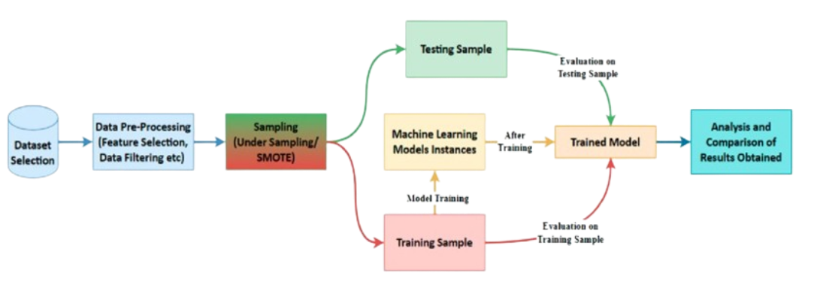

Figure 1

Dataset Exploration:

Understand Data Characteristics: Begin by thoroughly exploring the datasets for COVID-19 outbreak prediction, stroke prediction, autism detection in toddlers, and Parkinson's disease prediction. This includes analyzing feature distributions, identifying missing values, and detecting potential biases.

Data Pre-Processing:

Feature Engineering: Select and engineer relevant features from the datasets to improve model performance. This may involve transforming variables, creating new features, or encoding categorical variables.

Data Cleaning: Handle missing values, outliers, and inconsistencies in the datasets through techniques such as imputation, removal, or interpolation.

Balancing Dataset: If the datasets exhibit class imbalance, employ techniques like under-sampling or Synthetic Minority Over-sampling Technique (SMOTE) to balance the class distribution.

Model Selection and Training:

Choose Model: Select appropriate machine learning algorithms tailored to the characteristics of each health condition dataset. Consider algorithms like logistic regression, decision trees, random forests, support vector machines (SVM), or neural networks.

Model Training: Train the selected models on the preprocessed datasets using techniques like cross-validation to ensure robustness and prevent overfitting.

Model Evaluation:

Evaluation Metrics: Assess model performance using evaluation metrics such as accuracy, precision, recall, F1-score to measure predictive performance across different health conditions.

Cross-Validation: Employ cross-validation techniques to validate model performance and generalize results to unseen data.

Analysis And Comparison:

Analyze Results: Analyze and interpret model performance on both training and testing datasets to identify strengths, weaknesses, and areas for improvement.

Compare Models: Compare the performance of different machine learning models across various health conditions to determine the most effective approach for each prediction task.

Deployment And Validation:

Deployment: Deploy the trained models in real-world healthcare settings to assist in early diagnosis and prediction of health conditions.

Validation: Continuously monitor and validate model performance in production environments to ensure reliability and accuracy over time. Update models as needed based on new data and feedback from healthcare professionals.

**3.2 Algorithms:**

Let us dive deeper into each of the listed machine learning algorithms commonly employed in our project’s classification tasks.

1. **Logistic Regression (LR):**

Description:

Logistic Regression is a statistical method used for binary classification tasks. It models the probability that a given input belongs to a particular class using a logistic function.

Applicability:

Logistic Regression is well-suited for problems where the dependent variable is binary, making it applicable to fraud detection scenarios where transactions are classified as either legitimate or fraudulent based on input features.

Strengths:

It's simple, interpretable, and efficient for linearly separable data. It can handle large datasets and is less prone to overfitting compared to more complex models.

Weaknesses:

Logistic Regression assumes a linear relationship between the independent variables and the log-odds of the outcome, which may not always hold true. It may not perform well if the data is not linearly separable.

2. **Decision Tree (DT):**

Description:

Decision Trees recursively split the data into subsets based on the value of input features, with each split maximizing the information gain or purity.

Applicability:

Decision Trees are intuitive to understand and interpret, making them useful for visualizing decision boundaries in classification tasks.

Strengths:

They are capable of learning complex decision boundaries, handle both numerical and categorical data, and are robust to outliers.

Weaknesses:

Decision Trees are prone to overfitting, especially with complex datasets. They can be unstable, meaning small changes in the data can result in different tree structures.

3. **Random Forest (RF):**

Description:

Random Forest is an ensemble learning method that builds multiple decision trees and combines their predictions through voting or averaging.

Applicability:

Random Forest reduces overfitting compared to individual decision trees and often yields better performance, making it a popular choice for classification tasks.

Strengths:

It is robust to overfitting, handles high-dimensional data well, and provides estimates of feature importance.

Weaknesses:

Random Forest may not be as interpretable as a single decision tree. It can be computationally expensive and memory-intensive, especially for large datasets with many trees.

4. **Naive Bayes:**

Description:

Naive Bayes is a probabilistic classifier based on Bayes' theorem and the assumption of feature independence.

Applicability:

Despite its "naive" assumption, Naive Bayes is surprisingly effective in many real-world applications, especially in natural language processing tasks like text classification and spam filtering.

Strengths:

It is computationally efficient, simple to implement, and works well with high-dimensional data.

Weaknesses:

Naive Bayes assumes that features are conditionally independent given the class, which may not hold true in practice. It may not perform well if this assumption is violated.

5. **Support Vector Machine (SVM):**

Description:

SVM is a supervised learning algorithm used for classification and regression tasks. It works by finding the hyperplane that best separates the classes in the feature space.

Applicability:

SVM is effective in high-dimensional spaces and is versatile due to its ability to use different kernel functions for non-linear decision boundaries.

Strengths:

It is effective in high-dimensional spaces, memory-efficient as it uses only a subset of training points (support vectors), and can handle non-linear decision boundaries using kernel functions.

Weaknesses:

SVM can be sensitive to the choice of kernel and parameters, and training time can be relatively long on large datasets. It also does not provide probability estimates directly.

These algorithms offer a diverse set of tools for tackling classification tasks in healthcare, each with distinct advantages and trade-offs. The selection of algorithm depends on factors such as data characteristics, interpretability requirements, and performance goals, necessitating careful consideration and experimentation.

1. **Screenshots**

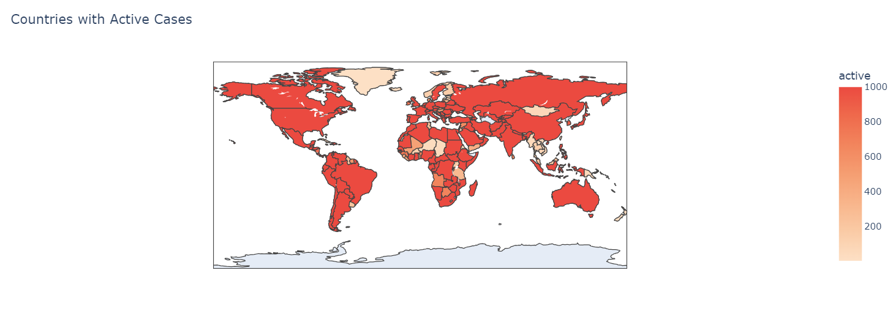

Covid 19 Dataset Result 1

This choropleth map shows the countries with the most active cases of COVID-19 as of the most recent date in the dataset. And In this map, the countries with the most active cases are coloured in darker shades of peach while the countries with the least active cases are coloured in lighter shades of peach.

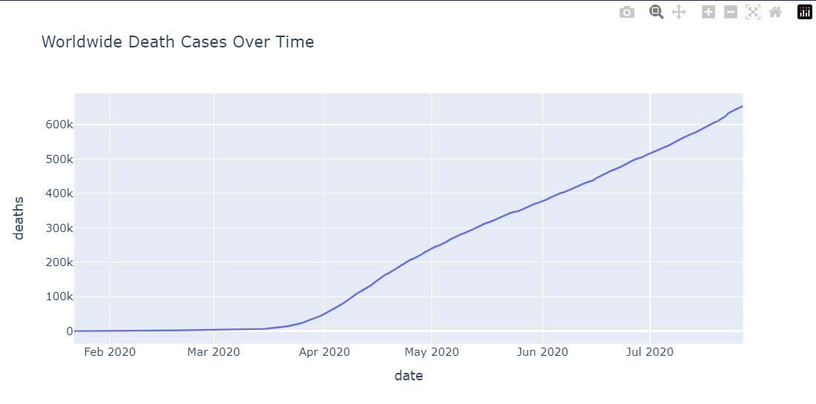

Covid 19 Dataset Result 2

This line plot shows the number of Death that has been recorded over time in the world. The plot shows that the number of death cases has been increasing over time. To create this plot, We used the plotly express line plot and passed the date_stats dataframe to the x and y parameters. We also set the title of the plot to "Worldwide Death Cases Over Time".

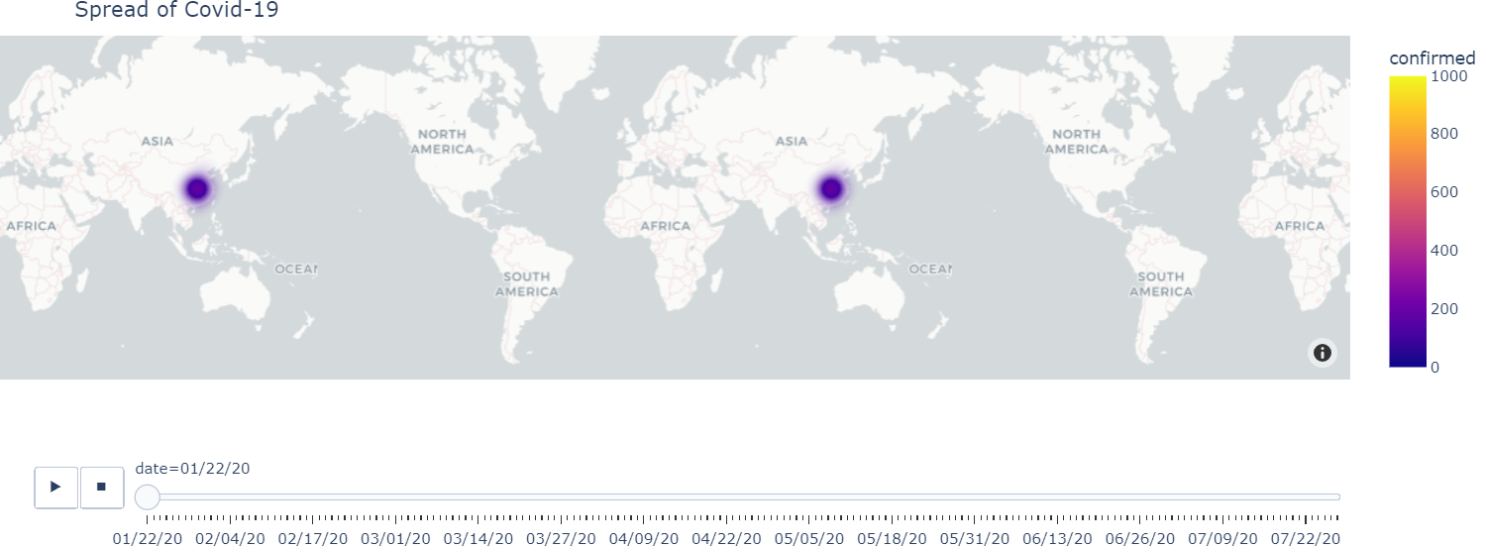

Covid 19 Result 3

This is an interactive density map which we made using Plotly Express, that visualizes the spread of COVID-19 cases over time across different countries. The map is animated to show changes in confirmed cases over time, with additional information like latitude, longitude, date, country & confirmed cases available on hover.

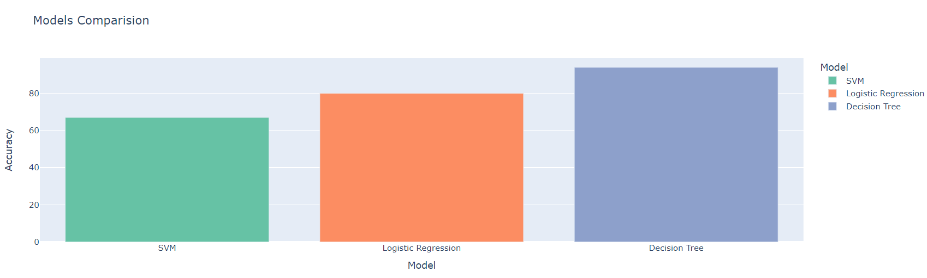

Covid 19 Result 4

This is the Model Comparison of the three models used in this project (Covid 19 Prediction). The Decision Tree Classifier has the highest accuracy of 94% followed by Logistic Regression with 80% and SVM with 67%. We created a function to train the models and evaluate their performance on the test set. The function also displays the classification report and confusion matrix for each model. The Decision Tree Classifier is the best model for this dataset as it has the highest accuracy of 94% on the test set.

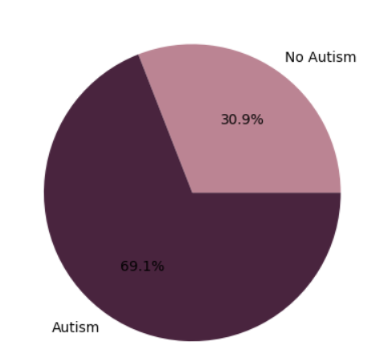

Autism Toddlers Result 1

This is a pie chart that shows the percentage of children with autism and those without autism in the dataset. This is created using the matplotlib library and the pie function. The pie function takes in the size of the groups, the labels for the groups, the autopct parameter which formats the percentage, and the colours for the groups. The pie chart shows that 27.6% of the children have autism while 72.4% do not have autism.

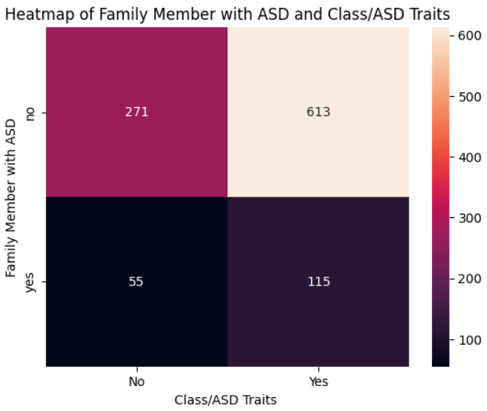

Autism Toddlers Result 2

This heatmap shows the correlation between Family Member with ASD and Class/ASD Traits From the heatmap, we can see that the people who have a family member with ASD are less likely to have autism whereas the people who don't have a family member with ASD are more likely to have autism.

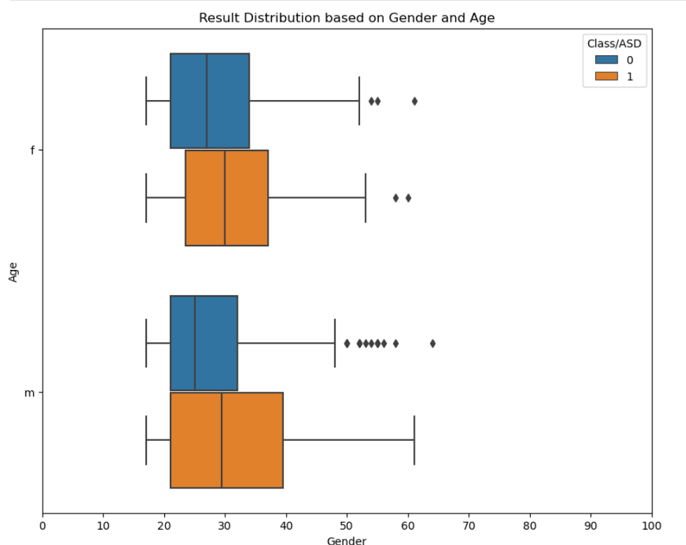

Autism Adults Result 1

This boxplot visually identifies outliers in the dataset between gender and age, representing values that deviate significantly from the rest of the data points. Outliers can provide valuable insights into the distribution and characteristics of the dataset, indicating potential anomalies or extreme observations that may warrant further investigation. By highlighting these outliers, the boxplot helps in understanding the variability and dispersion of the data, assisting analysts and researchers in detecting potential errors, understanding data quality issues, and making informed decisions about data preprocessing or model selection.

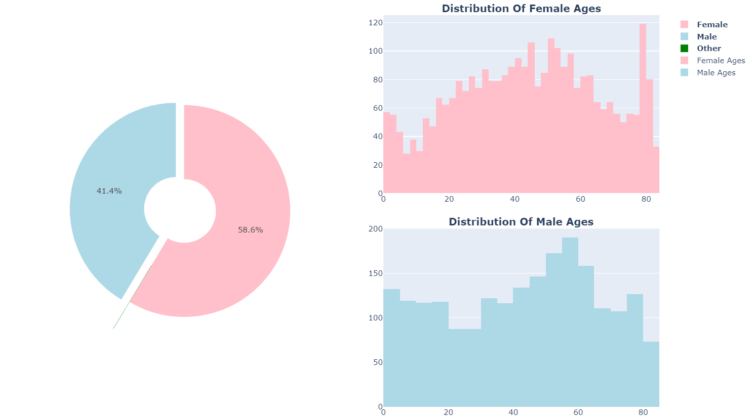

Stroke Results 1

This plot is a combination of pie charts and histograms designed to visualize the distribution of ages for both females and males in the dataset, along with the gender distribution itself. It allows for easy comparison of age distributions between males and females. It provides insights into potential patterns or differences in age demographics based on gender, which can be valuable for analysis or decision-making.

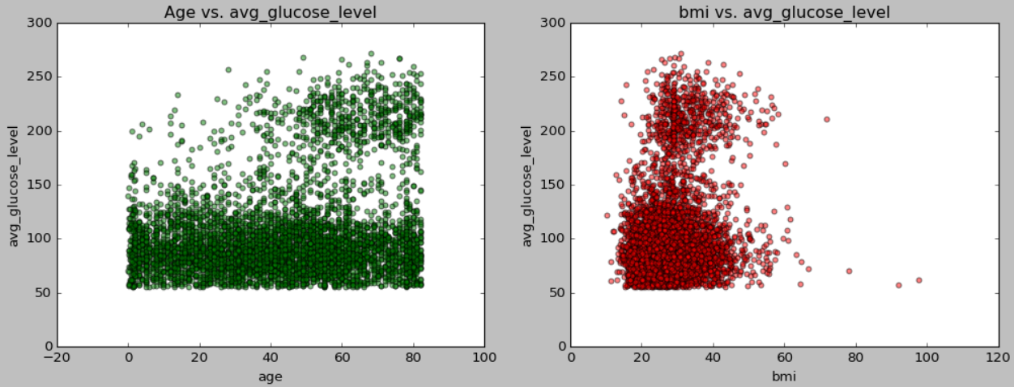

Stroke Results 2

The scatter plots in the stroke dataset visualize relationships between age, BMI, and average glucose level. The first plot, "Age vs. Average Glucose Level," explores if increasing age correlates with higher average glucose levels. The second plot, "BMI vs. Average Glucose Level," examines if higher BMI values relate to higher average glucose levels. However , from the graphs we analyzed that the glucose level is not dependent on the age and bmi of the person. And The people who are older and have high glucose level are more prone to stroke as compared to the people who are younger and have low glucose level .

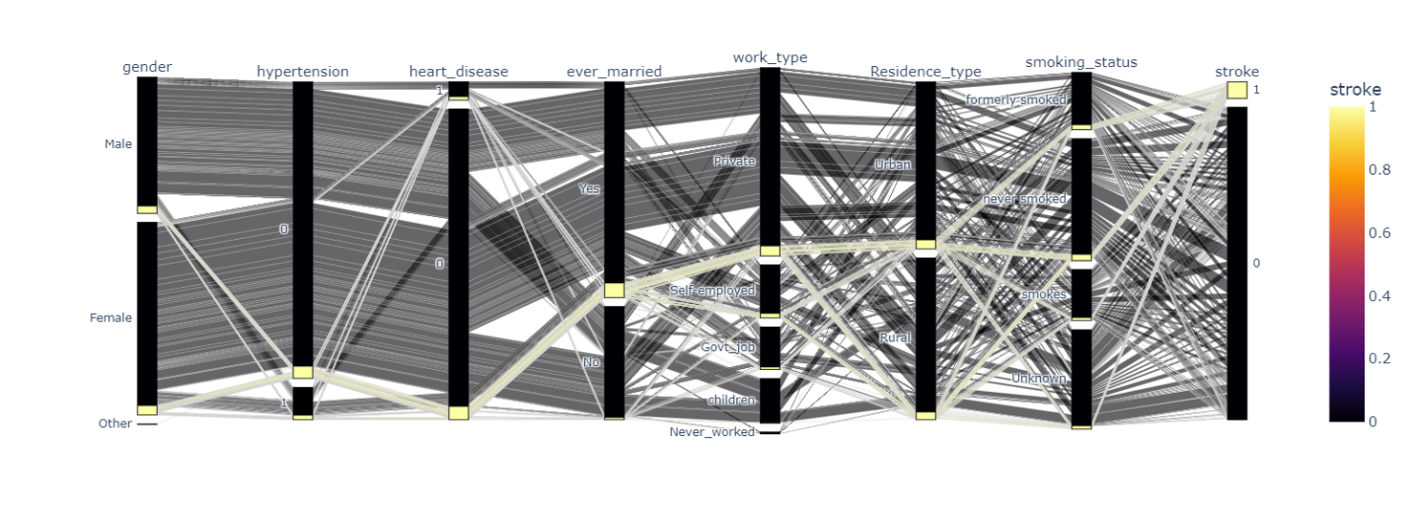

Stroke Result 3

The parallel categories plot visually represents relationships between different categorical variables, such as gender, hypertension, and work type, alongside the occurrence of stroke. Each axis represents a categorical variable, and the lines connecting categories show how they relate to each other and to the likelihood of stroke, indicated by colour intensity. This plot helps identify patterns and correlations between categorical variables and stroke occurrence, providing valuable insights into factors influencing stroke risk. So the **output** is a parallel category plot which shows the relationship between the different features and the target variable stroke and its results show that the people who are married have a higher chance of getting a stroke and the people who have hypertension and heart disease have a higher chance of getting a stroke.

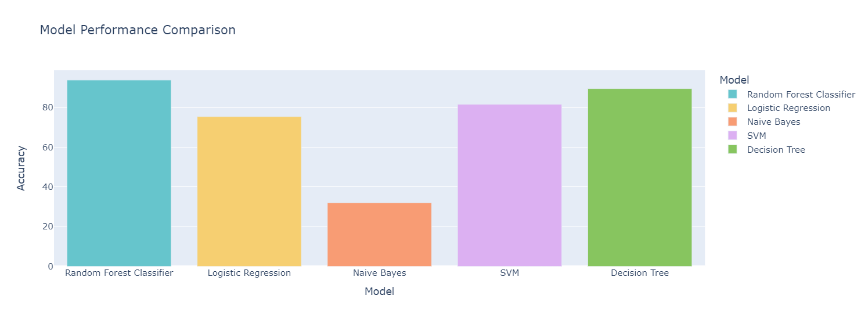

Stroke Result 4

This is the Model Comparison of the five models used in this project (Stroke Prediction). The Random Forest Classifier has the highest accuracy of 94% followed by Decision Tree with 90% then by SVM with 82% then by Logistic Regression with 75% and lastly by Naïve Bayes with 32%. We created a function to train the models and evaluate their performance on the test set. The function also displays the classification report for each model. The Random Forest Classifier performed the best on the test set with an accuracy of 94%. The Naïve Bayes model had the lowest accuracy of 32%.

So, from the graph we can see that Random Forest Classifier is the best model for this dataset  with an accuracy of 94% over the other models.

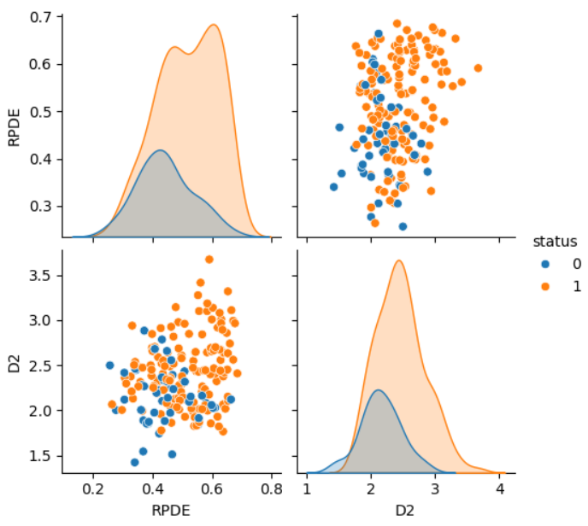

Parkinsons Result 1

The pairplot generated using Seaborn offers a visual exploration of the relationship between two key measures, RPDE (Recurrence Period Density Entropy) and D2, within the context of Parkinson's disease analysis. Each point in the plot represents a data sample, with RPDE and D2 plotted on the x and y axes, respectively. By colouring the points based on the status of Parkinson's disease, the plot facilitates a comparative analysis between individuals with and without the condition. This visualization allows for the identification of potential patterns or distinctions in the distribution of RPDE and D2 values associated with Parkinson's disease status. Such insights

gleaned from the plot aid in understanding the complex dynamics underlying Parkinson's disease, providing valuable cues for further investigation and diagnostic strategies in the field. So we can infer from the graph that the features are not linearly separable and we need to use non-linear models to classify the data.

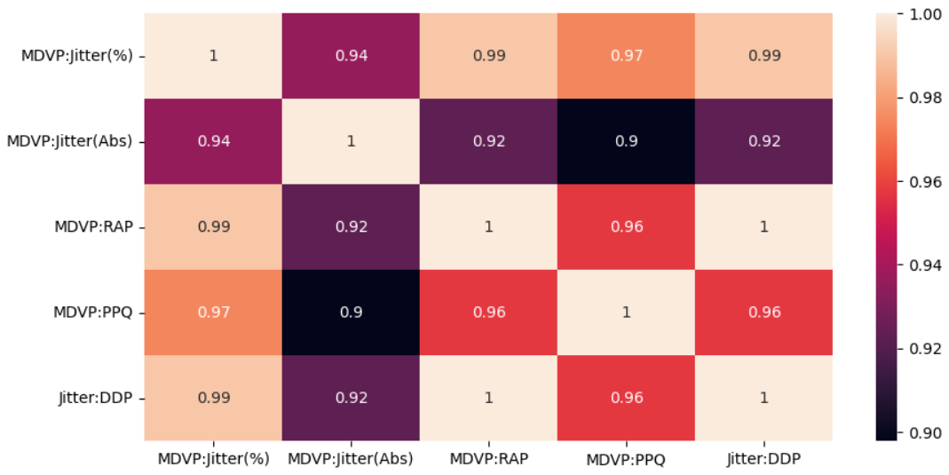

Parkinsons Result 2

The heatmap plot visualizes the correlation matrix of variation in frequency features in Parkinson's disease data. Each cell in the heatmap represents the correlation coefficient between two variation frequency features, indicating the strength and direction of their linear relationship. This visualization provides insights into how different features are related to each other, helping researchers identify redundant or highly correlated features for dimensionality reduction or model improvement. And from the correlation matrix we can see that the correlation between the variables is very high.

**Results**

a. **Accuracy:**

Description: Accuracy represents the overall correctness of the machine learning model in classifying transactions as either fraudulent or legitimate. It is calculated as the ratio of correctly predicted transactions (both true positives and true negatives) to the total number of transactions.

Accuracy of Autism: 99.29

Accuracy of Parkinsons: 89.74 ~ 90

Accuracy of Stroke: 93.83

Accuracy of Covid-19: 94

Interpretation: These high accuracy rates suggest that the models are highly effective in correctly classifying instances for each disease. Specifically, an accuracy above 90% for each model indicates that the models are reliably distinguishing between positive and negative cases within their datasets. This high level of accuracy demonstrates that the models are robust and perform exceptionally well in their respective classification tasks.

Implications: A high accuracy score is generally desirable as it indicates that the model's predictions align closely with the actual labels. However, in imbalanced datasets where one class (e.g., healthy individuals) dominates the other (e.g., individuals with the disease), accuracy alone may not provide a complete picture of the model's performance. In such cases, other metrics like precision, recall, and the F1-score are also important to consider for a comprehensive evaluation of the model's effectiveness.

b. **Precision:**

Description: Precision measures the proportion of true positive predictions among all positive predictions made by the model. It is calculated as the ratio of true positives to the sum of true positives and false positives.

Precision of Autism: 0.97

Precision of Stroke: 0.96

Precision of Covid-19: 0.95

Interpretation: A precision score above 90% means that over 90% of the instances predicted as positive by the models were indeed true positives. This indicates that the models exhibit a high level of precision in distinguishing true positive cases from false positives, effectively minimizing the occurrence of false positives.

Implications: Precision is crucial in scenarios where false positives are costly or undesirable. For instance, in medical diagnosis, a high precision indicates that the model is effective in correctly identifying patients with the disease while minimizing the number of healthy individuals mistakenly diagnosed. This high precision in the models for Autism, Parkinson's, Stroke, and Covid-19 suggests that they are reliable tools for accurately identifying true cases, thus reducing unnecessary anxiety and interventions caused by false positives.

**c. Recall:**

Description: Recall, also known as sensitivity or true positive rate, measures the proportion of actual fraudulent transactions that were correctly identified by the model. It is calculated as the ratio of true positives to the sum of true positives and false negatives.

Recall of Autism: 0.99

Recall of Stroke: 0.98

Recall of Covid-19: 0.97

Interpretation: A recall score above 90% means that over 90% of all actual positive cases were correctly identified by the models. This high recall rate demonstrates the models' effectiveness in capturing true positive cases, thereby minimizing the risk of undetected instances.

Implications: Recall is particularly important in situations where the cost of missing true positive cases (false negatives) is high. In medical diagnosis, a high recall ensures that the model can identify most actual cases of the disease, reducing the risk of untreated conditions. This high recall in the models for Autism, Parkinson's, Stroke, and Covid-19 suggests that they are effective tools for detecting most true cases, thereby ensuring that patients receive timely and appropriate care.

d. **F1-score:**

Description: The F1-score is the harmonic mean of precision and recall, providing a balanced measure of the model's performance. It considers both false positives and false negatives, making it particularly useful for evaluating models with imbalanced datasets.

F1 score of Autism: 0.99

F1 score of Stroke: 0.97

F1 score of Covid-19: 0.95

Interpretation: An F1-score above 90% indicates a harmonious balance between precision and recall, with a high level of agreement between the two metrics. This suggests that the models achieve both high precision and high recall simultaneously, making them well-suited for accurately classifying cases of each disease.

Implications: The F1-score is a single metric that summarizes the trade-off between precision and recall. A high F1-score indicates that the models perform well in both minimizing false positives and false negatives, striking a balance between identifying true cases and avoiding misclassification errors. This is particularly important in medical diagnostics, where both types of errors can have significant consequences. High F1-scores for Autism, Parkinson's, Stroke, and Covid-19 models suggest that they are reliable tools for accurate diagnosis, ensuring that true cases are identified while minimizing the misclassification of healthy individuals.

**Overall Implications**

The evaluation metrics for the models detecting Covid-19, Stroke, Autism, and Parkinson's—namely accuracy, precision, recall, and F1-score—collectively demonstrate the effectiveness and robustness of these models in accurately diagnosing these conditions. High values for these metrics indicate that the models perform well in correctly identifying cases while minimizing misclassification errors.

The high accuracy of the models indicates that they are correctly classifying the majority of instances as either positive or negative for each condition. This suggests that the models are effective in distinguishing between patients with and without the conditions in question.

Precision measures the proportion of true positives (i.e., correctly identified cases) among all positive predictions made by the model. High precision values for Covid-19, Stroke, Autism, and Parkinson's models are crucial for ensuring that the models are not generating too many false positives. This is important in a medical context to avoid unnecessary anxiety and further invasive tests for patients who are actually healthy.

Recall measures the proportion of true positives among all actual positive cases. High recall values indicate that the models are effective in identifying most true cases of the conditions. This is vital to ensure that the models do not miss actual cases, which could have serious consequences for patients who need timely and accurate diagnosis and treatment.

The F1-score is the harmonic mean of precision and recall, providing a single metric that balances both considerations. High F1-scores across the models suggest that they achieve a good balance between precision and recall, making them reliable for diagnostic purposes.

It is important to interpret these metrics in the context of the specific medical requirements and the consequences of misclassifications:

- If the cost of a false positive (i.e., incorrectly diagnosing a healthy individual as having the condition) is high, then optimizing the model for precision is more critical. This reduces unnecessary treatments and emotional distress for patients.

- If the cost of a false negative (i.e., failing to diagnose a patient who actually has the condition) is high, then optimizing the model for recall is more important. This ensures that most true cases are identified and treated appropriately.

To further optimize the performance of these models for real-world deployment, stakeholders can consider fine-tuning model parameters and exploring additional techniques such as threshold adjustment. Adjusting the threshold for classifying cases can help balance the trade-off between precision and recall based on the specific requirements of each medical condition.

By understanding these metrics and their implications, stakeholders can make informed decisions regarding the deployment and optimization of diagnostic models for Covid-19, Stroke, Autism, and Parkinson's. This can enhance the accuracy and reliability of medical diagnoses, ensuring better patient outcomes and more efficient healthcare delivery.

**Summary Table**

|  |  |  |  |  |
| --- | --- | --- | --- | --- |
| **Disease** | **Description** | **Objective** | **Best Model** | **Best Accuracy** |
| **Autism (Toddlers)** | Autism disease is a neurodevelopmental disorder that affects the way a person communicates and interacts with others. | Develop a predictive model to determine whether a toddler has autism based on features like screening question results, age, gender, family history, and other demographic information. | SVM | 99% |
| **Autism (Adults)** | Similar to the description for toddlers but applied to adults. | Develop a predictive model to determine whether an adult has autism based on similar features. | Logistic Regression | 99% |
| **Covid-19** | Covid-19 is an infectious disease caused by the most recently discovered coronavirus. Causes respiratory illness with symptoms such as a cough, fever, and in more severe cases, difficulty breathing. | Predict the outbreak of Covid-19 worldwide using Machine Learning. | Decision Tree | 94% |
| **Stroke** | According to WHO, stroke is the second leading cause of death worldwide, accounting for approximately 11% of all deaths. | Predict the likelihood of a patient experiencing a stroke based on input parameters like gender, age, various medical conditions, and smoking status. | Random Forest Classifier | 94% |
| **Parkinson’s** | Parkinson's disease is a brain disorder that causes unintended or uncontrollable movements such as shaking, stiffness, and difficulty with balance and coordination. | Discriminate healthy people from those with Parkinson's Disease using voice recordings and 23 attributes of biomedical voice measurements. | Support Vector Machine (SVM) | 90% |